

**NATIONAL UNIVERSITY OF SCIENCES & TECHNOLOGY**

**Digital Signal Processing (EE-330)**

Assignment 1 (CLO-1)

Getting Familiarized with DTFT and z – Transform

**Group Members**

|  |  |
| --- | --- |
| **Name** | **CMS ID** |
| Muhammad Ahmed Mohsin | 333060 |
| Muhammad Umer | 345834 |

**Submission Details**

|  |  |
| --- | --- |
| Submitted to: | Dr. Ahmad Salman |
| Class: | BEE-12C |
| Semester: | 6th |
| Dated: | 15/3/2023 |

# Introduction

Filter designing is an essential aspect of signal processing, which involves the selection of a suitable filter to process a signal. In signal processing, filters are used to extract relevant information from a signal or to remove unwanted noise or interference. The process of designing a filter involves selecting the type of filter, choosing the filter parameters, and optimizing the filter design to meet the desired specifications. The purpose of this assignment is to explore the various types of filters and their applications, with a particular focus on designing filters using the Filter Design and Analysis Tool (FDATool) in MATLAB.

# Design

1. Any transfer function with M-zeros and N-poles can be represented in z-transform as:

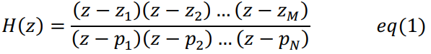

Remember, DTFT and z-transform are linked with . Our task is to design as system with the magnitude response as given below. Note that the dip to zero comes at around rad.

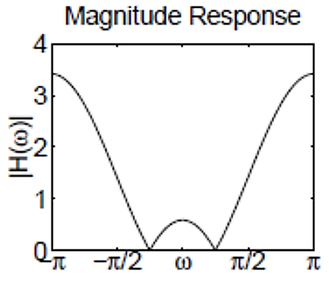

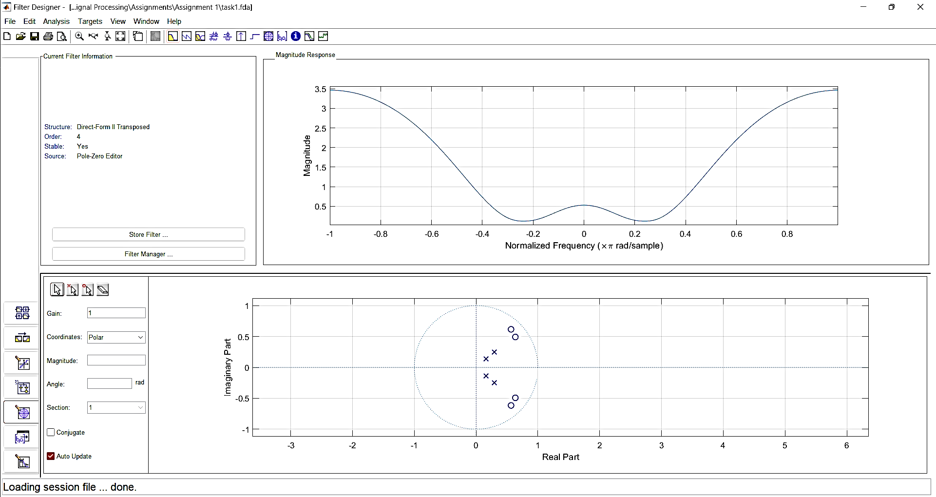

1. Write complete transfer function by hand for part 1.

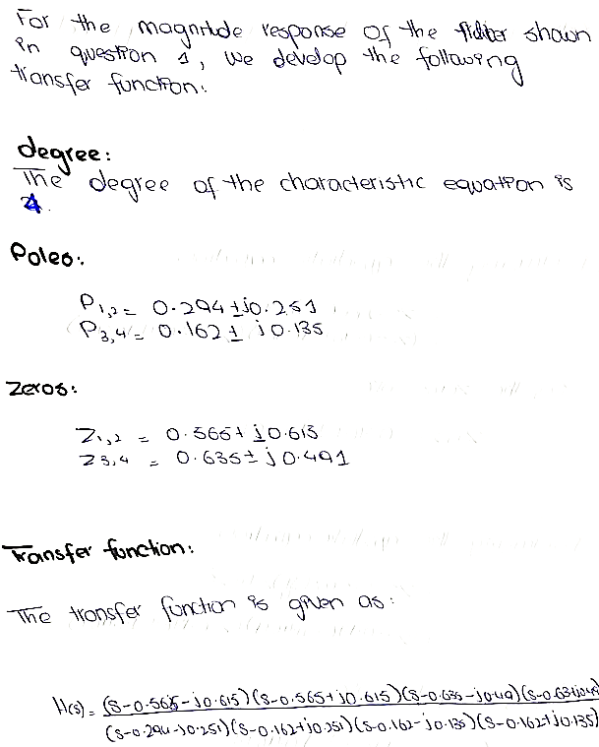

1. What should be done with poles and zeros to make the response look like below at rad and why?

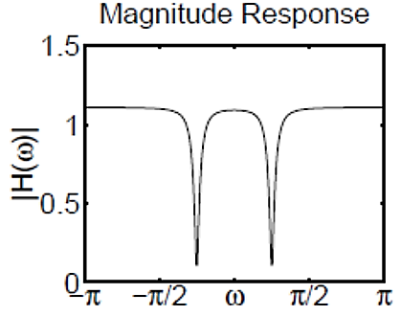

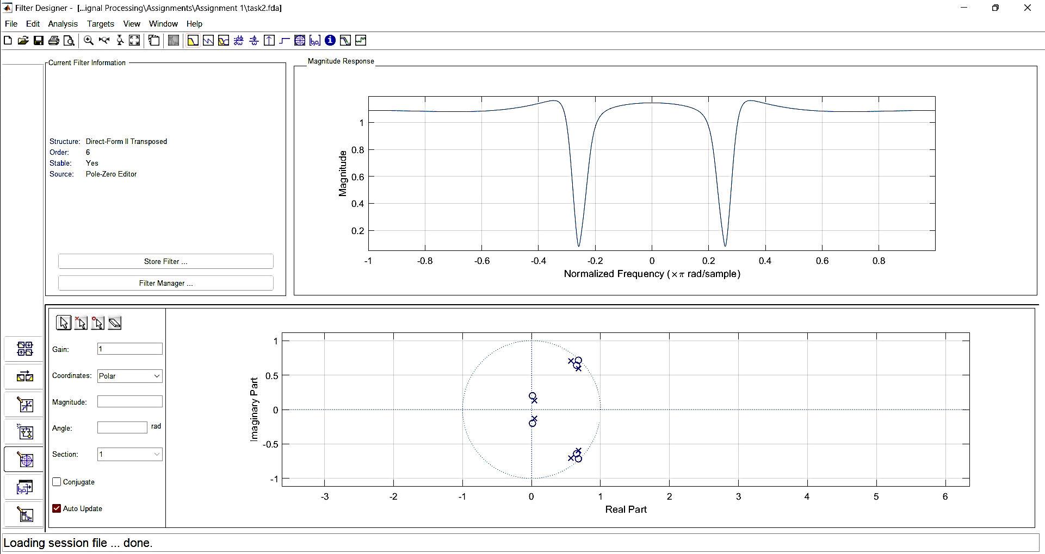

**Explanation:** To get the desired filter, we move the poles nearest to the respective zeros, and add an additional complex pole-zero pair to “sharpen” the dips at .

1. Repeat part 3 but get the following response approximately at 50 kHz.

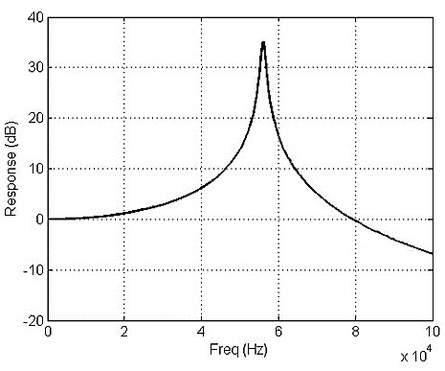

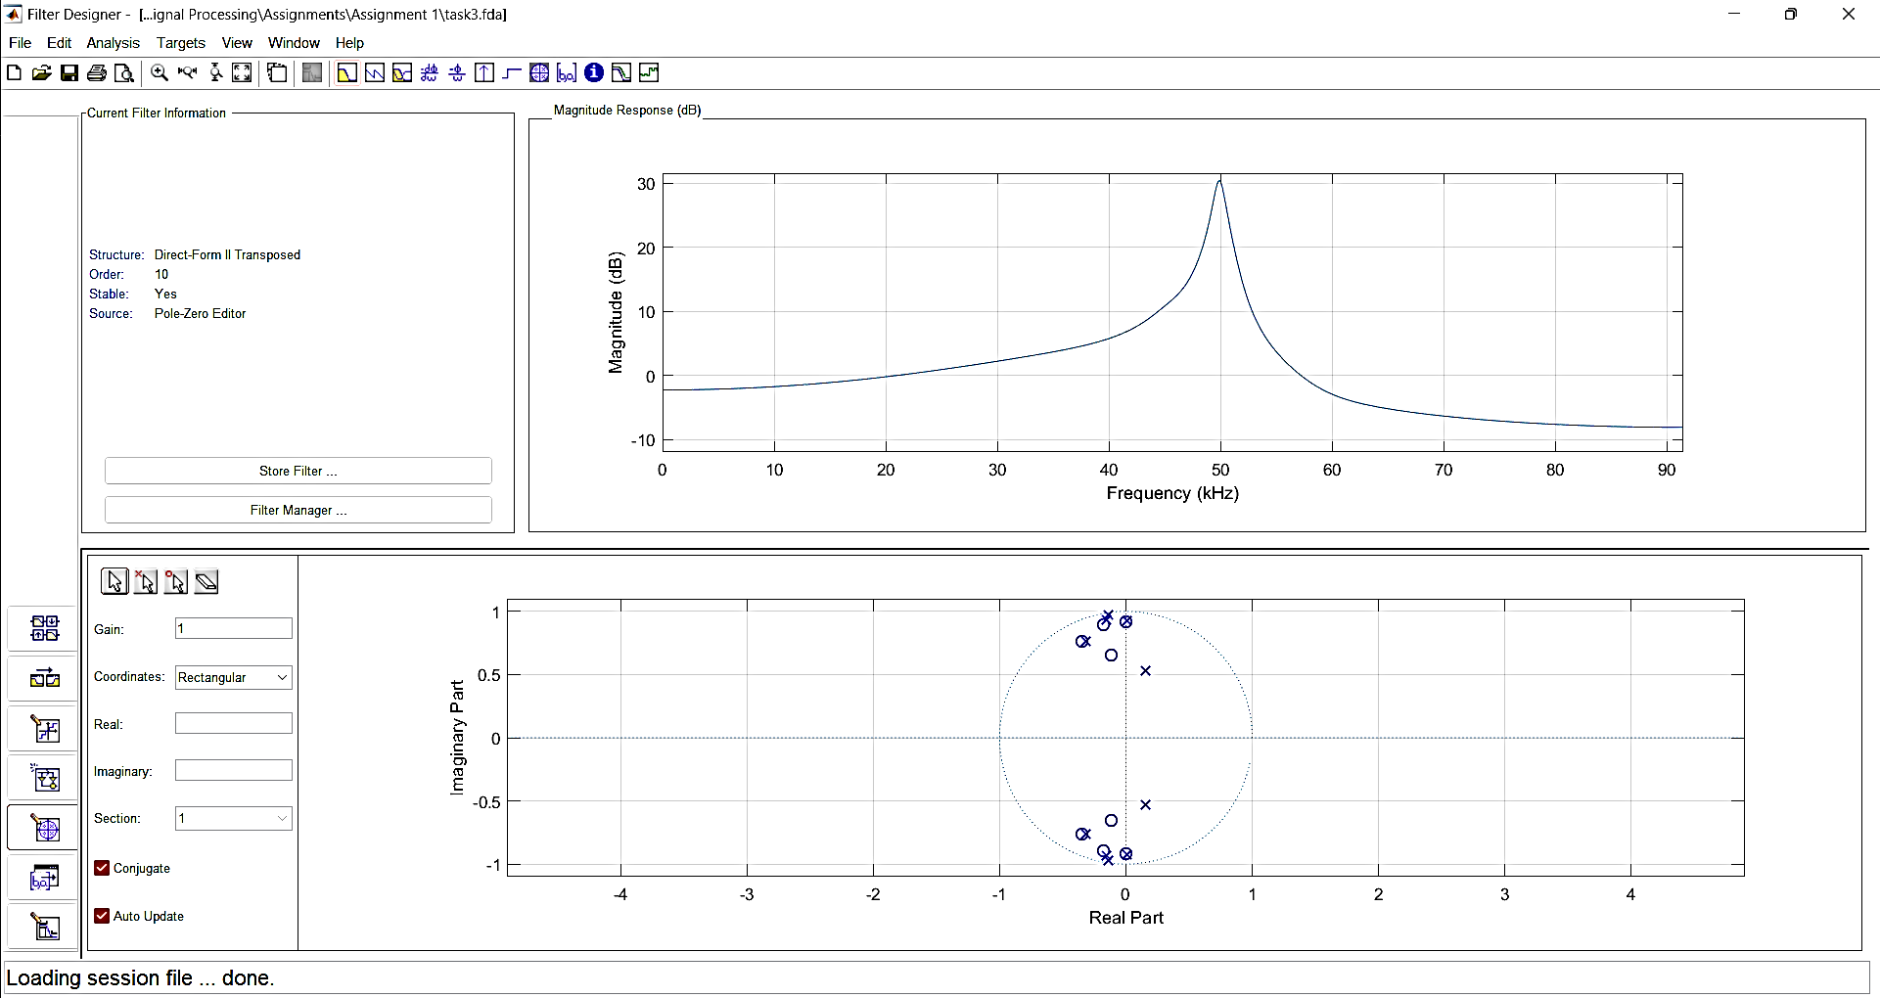

1. Find poles and zeros of the following transfer function by hand and write in the form of eq. (1), apply to “fdatool” and get the magnitude response.

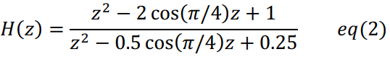

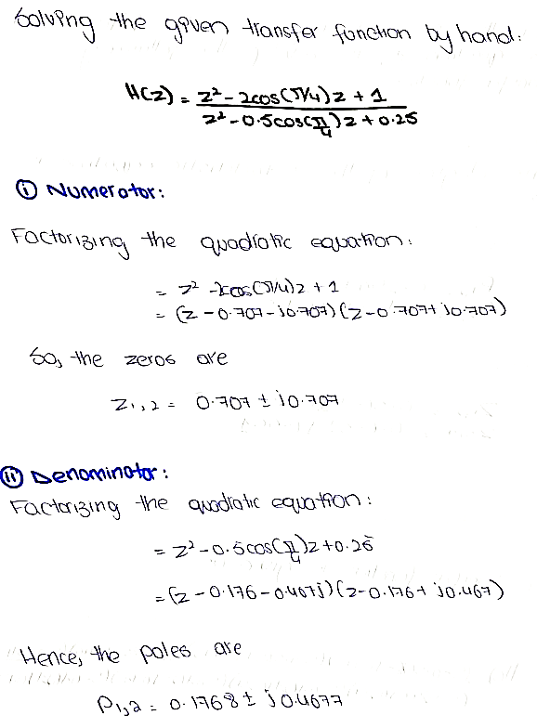

Hence, placing zeros and poles at and respectively in the Filter Designing Tool, we obtain the following response:

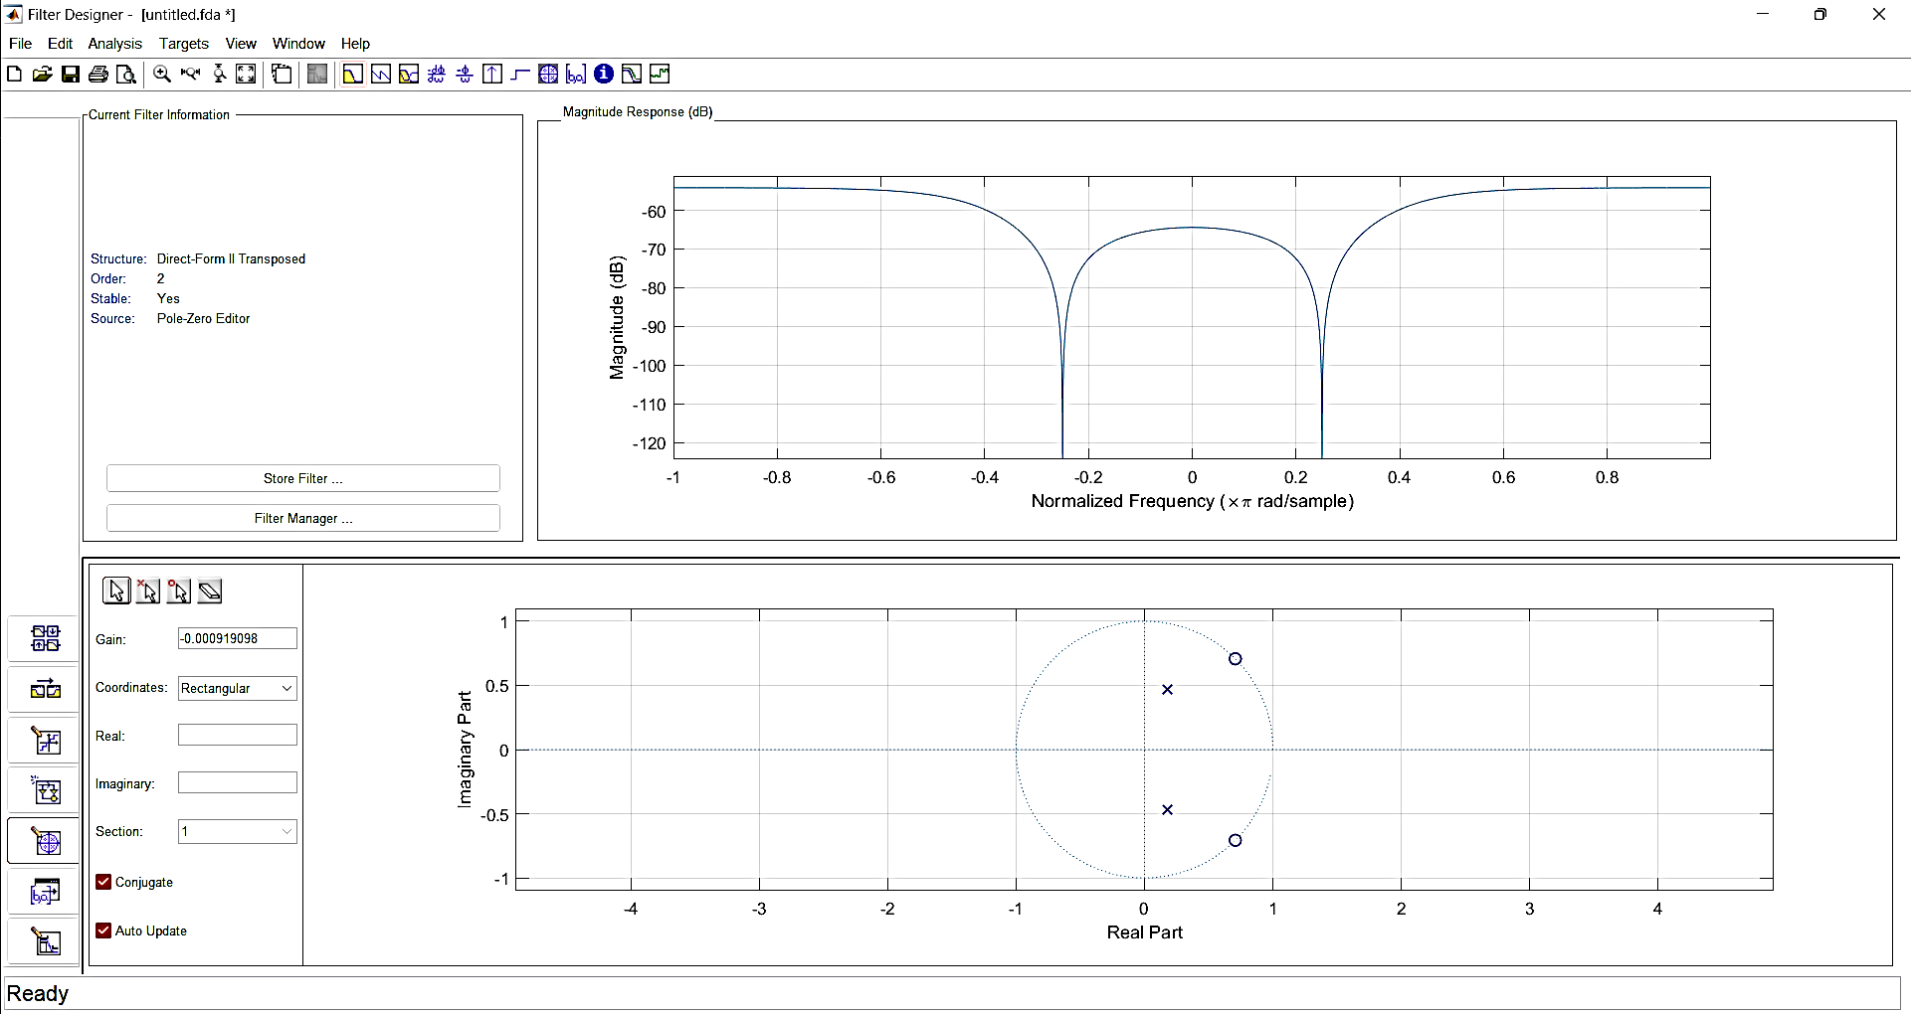

# Conclusion

MATLAB's FDATool provides a user-friendly interface that allows users to design and analyze filters efficiently. By using the FDATool, we can visualize the filter response, analyze filter performance, and choose the optimal filter type, order, and specifications to meet their specific requirements. Through this assignment, we have covered the fundamental concepts of filter design and demonstrated how to use the FDATool to design filters. Understanding the principles of filter design and being proficient in using tools such as MATLAB is crucial for signal processing professionals. Additionally, it is important to note that the discrete-time Fourier transform (DTFT) and the z-transform are two critical tools in signal processing, and are consistently made us of in digital signal processing.